**HTTP Protocol**

* **Used for server / browser communication**

**HTML -** [**https://developer.mozilla.org/en-US/docs/Learn/Getting_started_with_the_web/HTML_basics**](https://developer.mozilla.org/en-US/docs/Learn/Getting_started_with_the_web/HTML_basics)

* used to describe the **structure** and content of the web page. It defines the elements (like headings, paragraphs, buttons, and inputs) that appear on the page.
* <https://developer.mozilla.org/en-US/docs/Learn/HTML/Forms/Your_first_HTML_form>

**CSS (cascading style sheets) -** [**https://developer.mozilla.org/en-US/docs/Learn/Getting_started_with_the_web/CSS_basics**](https://developer.mozilla.org/en-US/docs/Learn/Getting_started_with_the_web/CSS_basics)

* used to define the **style** and **layout** of the elements described in the HTML. It controls characteristics such as colors, fonts, spacing, and positioning.

**JavaScript**

* Used to define the **behavior** of the web app, including what happens when the user interacts with the page (e.g., clicking a button, submitting a form, or typing in an input field).
* Transpilation is automatically configured in React applications created with Vite.
* [JavaScript language overview](https://developer.mozilla.org/en-US/docs/Web/JavaScript/Language_overview) 🡪 READ THIS NOW
* [You-Dont-Know-JS](https://github.com/getify/You-Dont-Know-JS) – free book series
* Another great resource for learning JavaScript is [javascript.info](https://javascript.info/).

**JSON** (JavaScript Object Notation)

* often used to **store, exchange, or transmit data** between the client (browser) and the server. Data entered by the user can be collected and encoded in JSON format for easy processing and transfer.

React – Library for web and native user interfaces

* <https://react.dev/>
* <https://react.dev/learn/your-first-component>
* Also, keep in mind that **First letter of React component names must be capitalized**.

Vite – Frontend build tool - <https://vite.dev/guide/>

* Reminder to use “npm run dev” to start the React application. Use on cmd line not Visual Studio.

NPM

* Npm, or Node Package Manager, is a free, open-source tool that helps web developers manage, build, and share JavaScript code packages. It’s a library and registry for JavaScript software packages.
* npm also has command-line tools to help you install the different packages and manage their dependencies.
* https://careerfoundry.com/en/blog/web-development/what-is-npm/#:~:text=npm%20stands%20for%20Node%20Package,kind%20of%20a%20big%20deal.

Fundamentals:

* Frontend / Backend - <https://en.wikipedia.org/wiki/Front_and_back_ends>
  + Browser is the Frontend. JavaScript that runs on the browser is the frontend code.
  + For class – Backend to be coded with JavaScript using Node.js runtime environment

Tools:

* Developer Console (Class example - <https://studies.cs.helsinki.fi/exampleapp/notes>) ctl-shift-i
* Git
  + <https://product.hubspot.com/blog/git-and-github-tutorial-for-beginners> ***
  + <https://webtuu.com/blog/04/a-laymans-introduction-to-git>
  + <https://education.github.com/git-cheat-sheet-education.pdf>
* Visual Studio Code - <https://code.visualstudio.com/> ***
* Node.js
  + open-source, cross-platform JavaScript runtime environment that allows you to execute JavaScript code outside of a web browser
  + npm and npx – use on Node.js cmd prompt
  + The code is written into files ending with .js that are run by issuing the command node name_of_file.js
  + It is also possible to write JavaScript code into the Node.js console, which is opened by typing node in the command line, as well as into the browser's developer tool console.
  + Express – Node.js web application framework <https://expressjs.com/>
* Mermaid - <https://mermaid.live/> for sequence diagrams
* jQuery - [jQuery](https://jquery.com/) Javascript library

Fullstack Resources:

* Submission System - <https://studies.cs.helsinki.fi/stats/courses/fullstackopen>
* Discord – Fullstack channel (Use channel, not chat)

General Resources:

* Tutorials – HTML, CSS, JavaScript, Python, SQL, etc :<https://www.w3schools.com/jsref/jsref_push.asp>
* 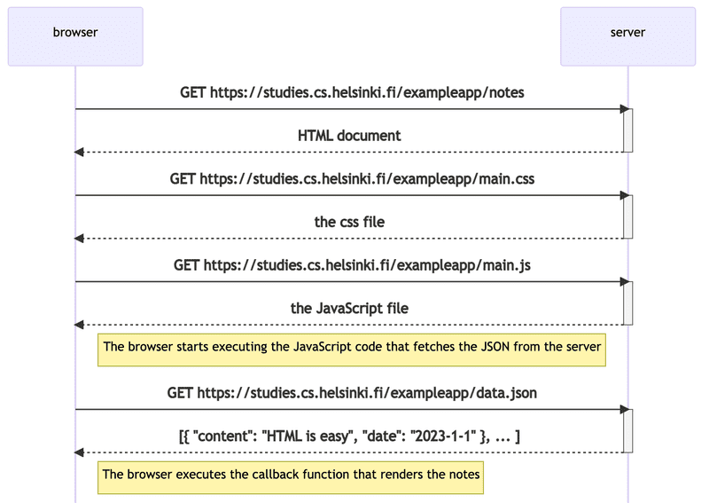

Section 1A

